FBI National Stolen Art File:
what was lost and what is missing

BY ALLI ARNOLD

a master’s capstone submitted to the Graduate Faculty in Data Analysis and Visualization in partial fulfillment of the requirements for the degree of Master of Sciences, The City University of New York

2025

© 2025
ALLI ARNOLD
ALL RIGHTS RESERVED

ABSTRACT

FBI National Stolen Art File:
what was lost and what is missing

BY ALLI ARNOLD

Advisor: Michelle McSweeney, PhD

This data exploration project studies the FBI’s National Stolen Art File (NSAF). My findings are presented with a series of data visualizations and a narrative into the data preparation process, with reflections on some of the broader challenges and opportunities offered by the NSAF.
The NSAF dataset is a public awareness tool and informational repository for known stolen artistic and cultural objects. By design, the objects in the NSAF should be of some value (presently limited to over $5,000 USD) and have some distinguishing features to allow for increased odds of future identification and restitution.
The data analysis and accompanying visualizations included in this capstone provide some limited examples of how further research and more consistent object data could be applied to identify patterns on the conditions (physical and contextual) that put cultural objects at risk for theft. The code repository is [WILL BE] publicly available at https://github.com/alliarnold/fbi_stolen_art_research.
The process of preparing the data for analysis provided the most telling takeaways. Engaging with object descriptions individually during the cleaning process illuminated how the dataset’s assembly and maintenance is impacting the effectiveness of finding some of those same objects.

ACKNOWLEDGMENTS

To my advisor, Michelle A. McSweeney, PhD
Your balance of enthusiasm, sincere curiosity, pragmatism made it possible for me to move forward with this project when I didn’t think I would. This project would not be done without you guiding me to do it.

To the faculty and staff at the Grad Center,
Thank you for the opportunity to learn from you; for imbuing data ethics and critical thinking into every aspect of study; for your industry knowledge and historical insights, your time, and your patience.

TABLE OF CONTENTS

ABSTRACT 3
ACKNOWLEDGMENTS 5
TABLE OF CONTENTS 6
DIGITAL MANIFEST 7
PROJECT INTRODUCTION 8
THE ART CRIME PROGRAM AND THE NSAF 9
PROJECT FRAMEWORK 12
DATA PREPARATION PROCESS 14
DATA ANALYSIS AND VISUALIZATIONS 15
KEY TAKEAWAYS 16
FUTURE POTENTIAL 17
BIBLIOGRAPHY 18

DIGITAL MANIFEST

- Capstone Whitepaper (PDF)
- Project website: https://alliarnold.github.io/INCOMING/
- Code and data: https://github.com/alliarnold/fbi_stolen_art_research [UPDATE PUSH INCOMING]

PROJECT INTRODUCTION

This data exploration project studies the over 4,000 stolen artistic and cultural objects catalogued in the FBI’s National Stolen Art File (NSAF).
When I embarked on this project, I hoped to reconfigure and expand on the information in the NSAF dataset so that I could explore potential patterns and relationships between various object variables. I suspected then, and still do, that identifying overarching patterns in the physical and contextual attributes of the lost objects may help identify other objects that are most at risk for cultural loss and may also help advance broader cultural restitution efforts.
After a tedious and slow start to editing the NSAF dataset, I ultimately had to adjust my intended project scope. The variety of object types included in the NSAF dataset requires niche areas of expertise to properly vet and to expand upon the object descriptions. Additionally, many object descriptions were missing important information and therefore require more time for conduct supplementary research. As a result, I had to largely abandon my original plan of analyzing a cross-category sample of the NSAF dataset. Instead, the data analysis components of my project focus on segmented samples from the following three object categories: Books and Ephemera, Drawings and Watercolors, and Paintings.
While this project does include some visualizations from my analysis of those three categories, for me, the most interesting takeaways from this exploration relate to what is missing in the descriptions and how the way that this dataset was compiled (or at least published) may be serving to extend the mysteries around the objects in it.

THE ART CRIME PROGRAM AND THE NSAF

Since its inception in 2004, the FBI’s Art Crime Program has recovered more than 20,000 items, with a total value of over one billion dollars USD. The program has three key elements: field investigations, a Rapid Deployment Art Crime Team, and the National Stolen Art File.

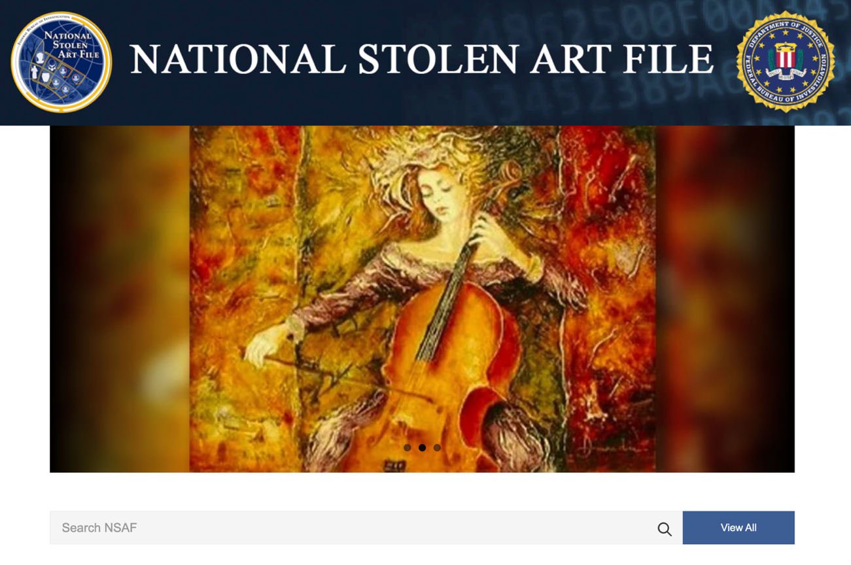
Figure 1: FBI's NSAF landing page, artcrimes.fbi.gov

The agents in the Art Crime Team are tasked with addressing art and cultural property crime cases within their assigned geographic regions, as well as assisting in art-related investigations worldwide in cooperation with foreign law enforcement and attaché offices. The Rapid Deployment Art Crime team itself is a group of highly trained investigators, working heavily with external subject matter experts domestically and abroad.
The Art Crime Team’s investigations span frauds and forgeries, antiquities trafficking, and violations of the Native American Graves Protection and Repatriation Act (NAGPR) and the Archeological Resources Protection Act (ARPA). Money is a key driver for cases being brought to the FBI Art Crime Team. Art crime is a multi-billion-dollar global market, spanning theft and illicit sales. The United States’ robust art market, unfortunately, makes the US a prime location for the buying and selling of illegitimate art from other countries. Despite significant progress being made in combating cultural property crime, it remains a growing industry, necessitating continued FBI resources.
The National Stolen Art File dates further back than the Art Crime Team. It began in 1979 and has evolved from a paper file system into a public website, and, now, a mobile app. The repository contains objects stolen in the United States and abroad, with each record containing various levels of information about the stolen objects.
For an item to be eligible to be included in the NSAF today, it must be valued over $5,000, the previous limit was $2,000. Additionally, the item should have some uniquely identifying characteristics, such as a distinguishing physical design with a photographic record, or a known artist’s edition with the recorded edition number. Over 8,000 objects have been registered in the NSAF. However, the public object count was at 4,561 at the time that I transferred the dataset from the NSAF website on August 25, 2024. This suggests that that once objects are found, or their criminal investigations are closed, they get removed from the public facing NSAF site. Or, perhaps, that not every NSAF object makes it onto the public listing. I suspect that the case is primarily due to the former, as many of the objects on the NSAF site appear to pre-date some of the current NSAF entry requirements, such as strong distinguishing features or values over $5,000. It is likely that the public NSAF dataset represents a mix of the oldest, hardest to close cases and the most recently reported objects. Indeed, many of the objects that appear to have older case files also have poorer quality catalogue entries, e.g. no images or poor-quality images, low value, and/or fewer identifying features.
It is not surprising that by the end of my data preparation process my vision for the project had shifted from data exploration and pattern identification to trying to understand how this dataset was assembled and how that process impacts any intentions to study it.

PROJECT FRAMEWORK

Art history and material cultural are innately intersectional fields that require a deep appreciation for where social context meets materiality. With that in mind, my approach to working with the NSAF dataset was heavily influenced by Catherine D’Ignazio and Lauren F. Klein’s Data Feminism and Johanna Drucker’s data humanist concept of data as capta not given, “something that is taken and constructed.”
In Data Feminism, D’Ignazio and Klein write, “The process of converting life experience into data always necessarily entails a reduction.” Each object description in the NSAF repository represents an abbreviated version of the long and twisty history of that object: who made it, who acquired it, how and why it was stolen and by who, and who was there to record the loss and how did they capture that information? With so many layers of context at play, understanding the data assembly and vetting process for the information in the NSAF has been both a key challenge and demand when editing and expanding upon the object descriptions in the NSAF.
The Art Crime Team are skilled investigators but they have limited resources to work backwards to long cold cases, and much of the public data provided in the NSAF does not appear to have been compiled by subject matter experts. Moreover, few of the object descriptions provide details about the context of an object’s theft or disappearance. The year for when an object’s theft was reported is not one of the standard catalogue points in the NSAF, nor is the object’s last known location. It may be entirely likely and reasonable that this information is withheld because NSAF objects are related to criminal investigations. However, those kinds of gaps in the data dampen researchers’ ability to study the missing objects and limit the general public’s ability to provide potentially useful information towards restitution efforts.
Due to the limited scope of this project and the limited public information available about the individual objects, I had to balance the need to interrogate the reported information with certain areas of acceptance and trust. While there were objects and I could, and ultimately did recategorize from paintings (something unique) to prints (a multiple, and generally less valuable) as part of my data interrogation, I did not have the privilege of distrusting artist attributions or considering if the any of the works were potential fakes or forgeries. The NSAF’s limiting requirement that all objects have a certain minimum financial value and the connection between insurance claims and police reports does, in the broader context of American society and wealth, indicate that the fine art objects in the NSAF are more likely to come from private collections with enough resources to have property insurance and/or museums. Therefore, the stolen objects’ most recent possessors had a greater likelihood of acquiring artwork through more vetted sources. Additionally, given the FBI Art Crime Program’s work investigating the creation and sale of artistic forgeries, we can hope that any object added to the NSAF after the Art Crime Program began in 2004 has had some level of further authenticity vetting.

DATA PREPARATION PROCESS

The NSAF repository presents stolen objects with one or more of the following informational elements:
- Image – sometimes an image of the artwork itself, sometimes a crime scene photo of the artwork in situ, and in at least one case, a drawing of what the object looked like based on a description
- Title – sometimes an official title other times an abbreviated description of the object
- Category – 80+ categories were used in the NSAF site, with frequent overlap and varying degrees of specificity, e.g. “Other – Jewelry”, “Jewelry – Pendant”, “Necklaces,” “Doors,” “Wine Cooler”
- Reference Number – there was not a public facing definition of this on the NSAF site, but it appears to be either a victim or a case number, some appear only once other have many associated objects
- Maker/Artist – use ranges from the name of the artist or manufacturer, to the artist’s expected culture or the believed place of production, e.g., “Alexander Calder,” “Asian,” “Lalique,” “France”
- Materials – use ranges from physical materials to production technic, e.g. “oil on canvas,” “wool,” “etching”
- Measurements – units ranged inches, feet, pounds, ounces, and centimeters
- Time Period – ranged from specific years, to larger date ranges, to approximate centuries, to era, e.g. “1979,” “circa 1884,” “1611-1650,” “19th century,” “Byzantine Empire,” “Before 1400”, “Contemporary,” “Copyright: 1983”
- Description – only visible after clicking through to an object’s unique page, ranged from detailed artwork descriptions, object provenance information, and further identifiers, to just a mix of key words
- Additional Information – ranged from additional descriptive details, object identifiers, and information on object to provenance, to just key words
Most objects in the dataset were missing at least one of the above elements in their entries.
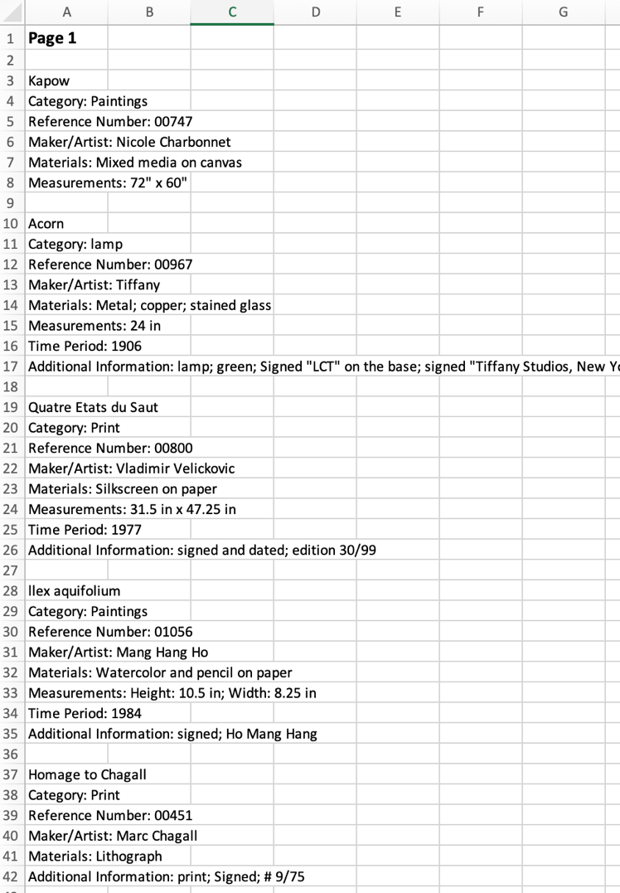
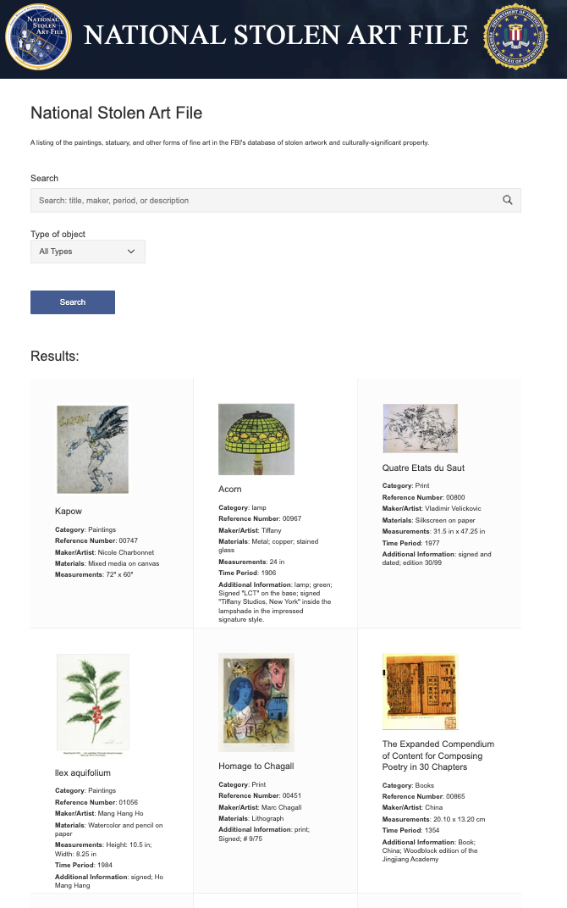
My first step in working with this NSAF data was to extract the object descriptions from the NSAF webpage. Surprising no one except myself, I quickly found that the FBI website had blockers preventing me from using the basic Python scrapping approaches I knew. After trying several different scrapping approaches, I was forced to fall back on copying-and-pasting the basic listing by navigating to the “View All” option on the search, and then copying and pasting the entry covers from each page of results into an Excel document. Doing the copy-paste approach for each paste in the database took hours, but that was just the beginning.
Figure 2 & 3: Screenshots of the "view all" results on the NSAF search and the initial copy-paste data in Excel

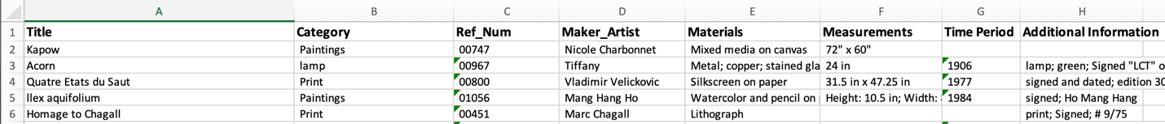
From there, I use Excel’s TEXTSPLIT function to separate the object variable labels (ex. “Materials:”) from information. I then transposed each set of object entries from columns into rows. Because each object did not contain the same complete set of elements, this step required many additional hours redistributing each object datapoint into consistently laid out columns before I had a dataset that I could trust for sampling.
Figure 4: Screenshot of the restructured data in Excel
Once I had the data in a structure that I could work with, I did an initial check of the number of categories used. At that time, I planned to use the category variable to create a stratified sample for my analysis. I found over 80 categories being used, over 100 if counting categories that were technically the same but written differently (ex. “other,jewelry” vs “Other – Jewelry”). I used Excel’s Pivot Table capacity to quickly count how many objects were fell under each category and then began to consolidate the categories. I began by combining the categories that were essentially the same (again, “other,jewelry”, “Other – Jewelry”, and “Jewelry”), then considered categories that overlapped with one another, such as “Dolls and Figurines” and “Figurines” or “Necklaces” and “Jewelry.” I checked and found there remained quite a few categories with less than objects in them, and made the decision to further combine categories to reduce the risk of any one object greatly skewing category-level analysis later. Using more common art and antiques cataloging subject groupings as my frame of reference, I was able to narrow the list of categories down to 27.
I was then finally ready to create my stratified sample. Using Python with the Pandas library in a Jupyter Notebook, I loaded the data into a Pandas DataFrame, confirmed the distribution of the objects across categories, and then pulled stratified sample of 10% of the NSAF data, with matching distribution of objects by category. And oh boy, if you think I lost time copying-and-pasting and then restructuring the data so I could sample it, then just wait for what I did next.
After considering what variables would be most interesting to explore for prospective patterns in the objects, I set out to expand upon the information on each of the 501 objects in my sample. I came to the following list table columns:
- Title – existing
- Category – existing
- Unique-Multiple – new addition, for differentiating unique works or editions
- Image - new addition to flag if an object record had an image (Y/N)
- Reference Number – existing
- Maker_Artist – repurposed to only list artist name
- Artist_2 – new addition for collaborative objects, or works with separate manufacturer, ex. books and artists’ editions
- Artist_Culture – new addition, for the first artist’s culture
- Artist_2_Culture – new addition, for the second artist’s culture
- Manufacture_Country – new addition for the country where an object was made
- Materials – existing
- Material_Primary-Base – new addition for the object’s primary material
- Material_Secondary – new addition for the object’s secondary material
- Material_Regulated-Endangered – new addition, Y/N on material regulation
- Measurements – existing
- Height-Length – new addition, splitting measurements by type
- Width – new addition, splitting measurements by type
- Diameter_Depth – new addition, splitting measurements by type
- Largest Dimension – new addition, splitting measurements by type
- Weight – new addition, splitting measurements by type
- Time Period – existing
- TP_Start – new addition, first year of creation time range
- TP_End – new addition, last year of creation time range
- Manufacture_Start – new addition, first year of manufacture time range
- Manufacture_End – new addition, last year of manufacture time range
- Color-Primary – new addition, predominant object color
- Additional Information – existing, combines text from “Description” and “Additional Information” variable labels
When I started working my way through the sample data, I had one more “Y/N” variable to flag if an object was created in a context of conflict, e.g. if there was a known war occurring in the country where it was created when it was created. With the numerous wide time frames and varying degrees of conflict documentation, I had to let go of this variable first. I accepted this in part because I believe that the more useful information would be if the object was first recognized as stolen during a conflict—unfortunately, as already mentioned, the date and place of the reported thefts is not provided for the NSAF objects.
The other major mistake I made when I started working my way through the object data was to start at the top of the sample, which was pulled with the objects ordered alphabetically by category. For context, my first master’s is an MA in the Connoisseurship of Fine & Decorative Art through University of Manchester’s Sotheby’s Institute of Art program, and I have worked for several auction houses, most recently serving as generalist specialist and head cataloguer. Despite, many of these objects in the NSAF are beyond my existing expertise. My knowledge base leans heavily on fine arts and books and ephemera. While I can muddle through researching and identifying many antiques through in-person physical inspection, I do not have subject matter expertise to identify and vet time periods for ancient coins without extensive supplemental research. I lost hours researching individual objects before I finally accepted that I would not be able to complete this project on my own anytime soon if I continued down with that path. I knew enough to spot inaccuracies and inconsistencies in the information on certain objects (for example, objects assigned as being produced by one indigenous people while also being described as having been made in a region not historically associated with those people), but I did not know enough to correct or fill-out my additional variables with any speed. I reluctantly accepted that I needed to let go of my original desire to do a comprehensive sample, accepted that the time I spent preparing and researching some of the objects was lost, and that I needed instead to narrow my sample for this project to just the categories where I had a stronger knowledge base.
Once I shifted focus, I was able to move more quickly and more accurately, though there were certain cases and variables that slowed me down more than others. The country of creation variable for example demanded more time to pin-down when dealing with artists who moved regularly throughout the career. I was also more confident in recognizing mischaracterizations and time period errors. For example, many works that were associated with artists who lived in the 1800s had “18th century” listed as their time period. I found that many object time period’s listed with the centuries being misapplied. I also found many watercolors on paper erroneously categorized as paintings, when they would more accurately fall under the drawings and watercolors category. I also found prints described as paintings, despite the artwork image being of a print and that object details listing information on the publisher. Recategorizing certain objects resulted in shifted sample sizes for the three categories I completed. However, I am hopeful that those shifting sample sizes are reflective of what a more accurate breakdown of the objects in the NSAF. Objects in the books and ephemera category often lacked dimensions and often did not specific which pressing the lost volume was. Fortunately, most books with modern printing records were produced in standardized sizes, so I was able to find their dimensions by finding information on the relevant edition through rare book library pages and rare book sales listings.
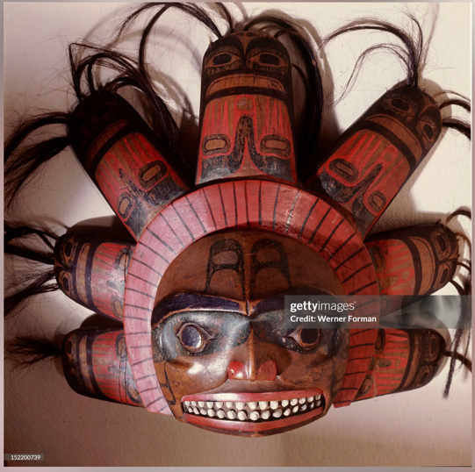
While researching these objects, I found numerous echoes of their continued existence out in the world.
Early on, I found what appeared to be the same Nisga'a carved mask, with matching provenance, on a webpage for the Smithsonian Museum of the American Indian.
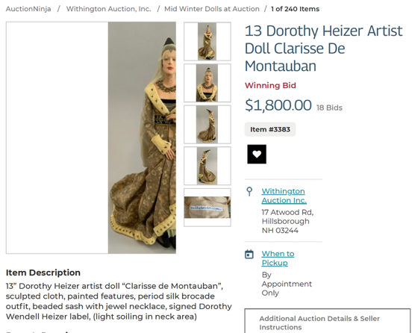
I came across an auction record for what appears to be the same, supposedly unique, hand-made silk doll by Dorothy Heizer.
I also found auction record for a set design by Nicolai Konstantinovich Kalmakov when I was researching the painting’s time period.
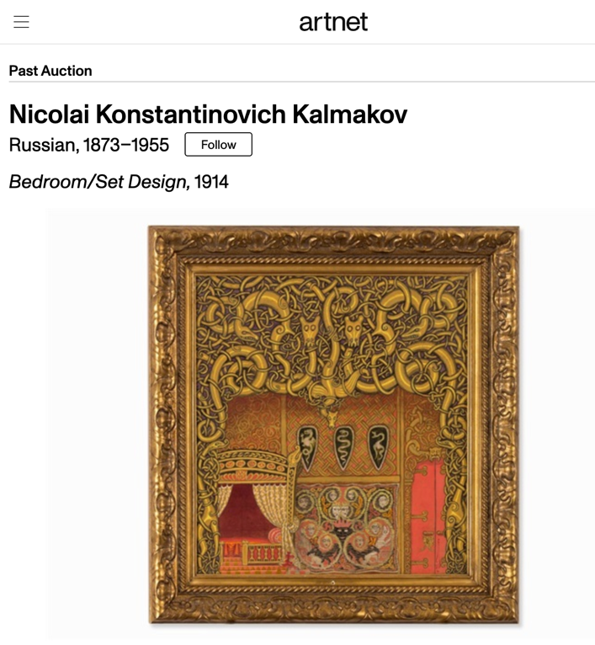
More surprisingly the images from that artwork’s auction record suggest that it was offered at auction two years in a row, in 2014 and again in November 2015.
Following each of these discoveries, I just kept trucking until I eventually completed the entries for the objects in at least three object category samples.

As the NSAF does not divulge when the objects in the database were reported stolen, it is hard to say if any of these matches are clues to where the objects are today, or if what I found is just object provenance predating the theft.
If my research uncovered information that pre-dates these objects’ theft, then the absence of these details from the NSAF is telling example of how having the works submitted to the NSAF by local police without specialized training results in key gaps in object cataloging. If my research did find clues about where these objects have gone, the only way for me to know is to try submitting a tip to the FBI.

DATA ANALYSIS AND VISUALIZATIONS
Notes…
- Categories bar chart (pre-sampling)
- Object creation map by categories: books, paintings, watercolors/drawings
- Bar of object maker culture by categories: books, paintings, watercolors/drawings, with stack of primary and secondary artist cultures
- Ghant chart of timelines
- Charts of object sizes, by category and all together
- Bar chart for paintings and drawings/watercolors predominant color

KEY TAKEAWAYS

Notes…
- Clear that the object data has been collected by sources with differing levels of subject matter expertise… non-specialized police departments reporting the theft or the most recent known owner misattribution or recollection of an object

- More recent public statements from the FBI (2023 podcast interview) flagged that they want the work to have distinguishing features, quality images, and be worth $5,000. The Art Crime Program Manager goes as far as to explain why ancient gold coins are a tricky and unlikely to be found. It does not seem like objects entered into the NSAF before those requirements were tightened get removed if they don’t reach current thresholds.

- Many of the objects I reviewed would have fair market values well below $5,000 or even the former valuation of $2,000. I blame this on the link between insurance filings that require losses being reported to the police in order to be paid, and police then being shown inflated values on objects, which are then reported to the FBI. In the field of art appraisal, it is understood that insurance estimates are often inflated. In cases when artwork may have been stolen from a gallery or a private resident, a gallery would be likely to list the maximum retail price of the lost work for insurance, even if it is highly unlikely a work would be sold for that amount, and the achievable price for the artwork would have required some level of discount to collectors. Similarly, I saw works that were marked as original paintings which by description were clearly prints, suggesting that some residents may have misunderstood what they had and the value of what they had when the works were reported to insurance and the police.

FUTURE POTENTIAL
Notes…
- Next categories: Prints, photos, sculptures to be able to pull more cross-category patterns within the fine art object categories

- Submit any public sales data on the objects to the FBI as tips just in case

- Check another country’s lost paintings with INTERPOL app, and compare patterns in US stolen art list with another countries stolen country’s stolen paintings for overarching patterns

BIBLIOGRAPHY

D’Ignazio, C., & Klein, L. (2020). Data Feminism. Retrieved from https://data-feminism.mitpress.mit.edu/

Drucker, Johanna. “Humanities Approaches to Graphical Display.” Digital Humanities Quarterly, vol. 5, no. 1, 2011.

SMU DataArts. Arts Vibrancy Map. Received from https://dataarts.smu.edu/ArtsVibrancyMap/

Burns, Charlotte, & Halperin, Julia. The 2022 Burns Halperin Report. Artnet, December 2022. Retrieved from https://news.artnet.com/art-world/burns-halperin-report

Thornes, Robin, with contributions by Dorrell, Peter and Lie, Henry. Introduction to Object ID: Guidelines for Making Records that Describe Art, Antiques, and Antiquities, 1999. Retrieved from https://www.getty.edu/publications/virtuallibrary/0892365722.html

International Council of Museums and J. Paul Getty Trust. Object ID. ICOM, 1999. Retrieved from https://icom.museum/en/resources/standards-guidelines/objectid/

FBI, “National Stolen Art File, FBI Art Crime Program, August 25, 2024. Retrieved from https://artcrimes.fbi.gov/
FBI, “Art Crime,” Federal Bureau of Investigations, December 26, 2025. Retrieved from https://www.fbi.gov/investigate/violent-crime/art-crime
Ellen Ferrante, host, with Kristin Koch, guest, “The Art Crime Program,” in Inside the FBI Podcast, produced by the FBI, November 1, 2023. Retrieved from https://www.fbi.gov/news/podcasts/inside-the-fbi-podcast-the-art-crime-program

FBI, FBI Art Crime Team Marks 10-Year Anniversary, FBI.gov, February 9, 2015. Retrieved from https://www.fbi.gov/video-repository/newss-fbi-art-crime-team-marks-10-year-anniversary/view
FBI, FBI Art Crime Team Training, FBI.gov, February 5, 2010. Retrieved from https://www.fbi.gov/video-repository/newss-mp4-art_crime_training.mp4/view

FBI, “Art Crime,” Federal Bureau of Investigations, December 26, 2025, https://www.fbi.gov/investigate/violent-crime/art-crime
Ellen Ferrante, host, with Kristin Koch, guest, “The Art Crime Program,” in Inside the FBI Podcast, produced by the FBI https://www.fbi.gov/news/podcasts/inside-the-fbi-podcast-the-art-crime-program
FBI, “Art Crime,” Federal Bureau of Investigations, December 26, 2025
Ellen Ferrante, host, with Kristin Koch, guest, “The Art Crime Program,” in Inside the FBI Podcast
Ibid
Ibid
FBI, February 9, 2015, FBI Art Crime Team Marks 10-Year Anniversary, FBI.gov, https://www.fbi.gov/video-repository/newss-fbi-art-crime-team-marks-10-year-anniversary/view
Ellen Ferrante, host, with Kristin Koch, guest, “The Art Crime Program,” in Inside the FBI Podcast
Ibid
Ibid
Ibid
FBI, March 13, 2013, FBI Art Theft Program, FBI.gov, https://www.fbi.gov/video-repository/newss-fbi-art-theft-program/view
Ellen Ferrante, host, with Kristin Koch, guest, “The Art Crime Program,” in Inside the FBI Podcast
Ibid
Drucker, Johanna. “Humanities Approaches to Graphical Display.” Digital Humanities Quarterly, vol. 5, no. 1, 2011.
D’Ignazio, C., & Klein, L. (2020). “Introduction: Why Data Science Needs Feminism” in Data Feminism. Retrieved from https://data-feminism.mitpress.mit.edu/

